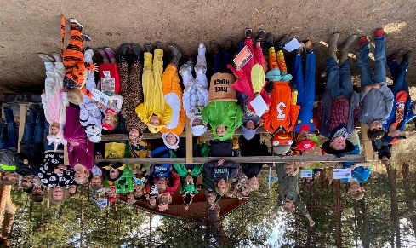



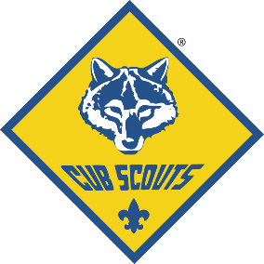
Pack Activity Calendar 2024

August
27 – Tues. 1st - Pack Meeting

September
10 – Tues. Den Meetings
24 – Tues. Pack Meeting

October
8 – Tues. Den Meetings
11-13 Cub Haunted Campout
22 – Tues. Pack Meeting

November
5 – Tues. Den Meetings
19 – Tues. Pack Meeting

December
3 – Tues. Den Meetings
17 – Tues. Pack Christmas Party
PARENT ORIENTATION MEETING!
Learn everything you need to know for the upcoming program year! Free Cub Scout Handbooks will be handed out. Activities for your Scout(s) to do.

6:30pm on Tuesday, August 20th
at Oak Park School, XXXXX Oak Park Drive
Funding
Our annual pack dues are $70 and are paid in November, but most Scouts don’t ever pay anything out of pocket. Each Scout has an account in Scoutbook that tracks funds used to pay for the activities they chose to participate in.

Scouts provide funding to this account by:
- Participating in our Council’s Popcorn fundraiser. This occurs in the fall. 80% of the commission earned will be attributed to the Scouts account in Scoutbook. Participation is optional.
- Participating in the Council’s Spring fundraiser. This sale has multiple options. 80% for the commission earned will be attributed to the Scouts account in Scoutbook. Participation is optional.
- Scouts can also “write a check” to cover activity expenses.

ATTEND CUB HAUNTED!
Our 1st campout is Cub Haunted at Camp Jack Nicol!
Haunted Hayrides! BB’s and Archery!
Haunted Castle!
Costume Contests!
Nature Hikes!
Fun for the whole family!

Welcome to Pack 123!
QUESTIONS? Pack Leadership Contact Information:
CUB MASTER: John Doe 555-555-5555 johndoe@gmail.com
COMMITTEE CHAIR: John Doe 555-555-5555 johndoe@gmail.com

